INTRODUCTION AND WORKING OF AN RC CAR

INTRODUCTION:

An RC (Remote-Controlled) car is a small, motorized vehicle that can be driven from a distance using a handheld transmitter. These cars are powered by batteries or fuel and come in various styles—ranging from rugged off-road trucks to sleek racing cars.

RC cars are more than just toys—they're a popular hobby for enthusiasts of all ages. They offer hands-on experience with mechanics, electronics, and driving skills. Whether you're racing on a track, performing stunts, or just cruising around your backyard, RC cars deliver excitement, learning, and fun in one compact package.

INTERNAL BLOCK DIAGRAM:
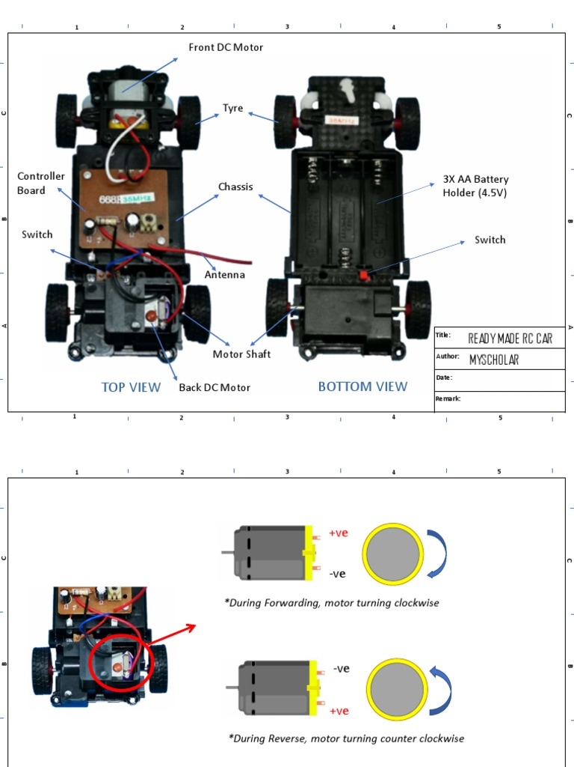

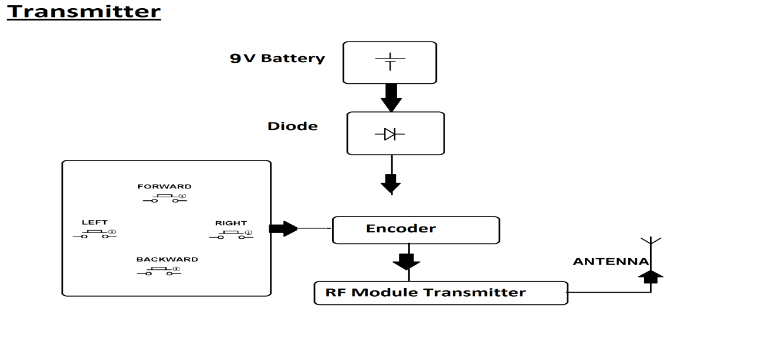

INTERNAL COMPONENTS AND DETAILED EXPLANATION:

REMOTE CONTROL
|
(RF Signal)
|
----------------
| Receiver / |
| Control | ← (Green PCB board)
| PCB |
----------------
| |
Left Motor Right Motor
(DC) (DC)
| |
Left Wheels Right Wheels

|
Battery
(3V / 6V)
|
Power Supply

EXPLANATION:

Battery:

The battery supplies electrical power to the entire RC car. It provides the required voltage to run the control circuit and the motors.

Receiver / Control PCB:

This is the main control unit of the RC car. It receives radio signals from the remote control through the antenna wire. Based on the signal received (forward, backward, left, or right), the control PCB decides which motor should run and in which direction.

Antenna:

The antenna wire helps the receiver PCB to capture radio frequency signals sent by the remote control.

DC Motors:

The RC car usually has two DC motors. One motor drives the left wheels and the other drives the right wheels. By changing the speed or direction of these motors, the car can move forward, backward, and turn left or right.

Gear and Wheel System:

The motors are connected to gears and wheels. The gear system increases torque and helps the car move smoothly on the surface.

FUNCTION&WORKING PRINCIPLE:

The primary function of an RC car is to simulate real vehicle movement on a smaller scale, controlled remotely by a user. It allows for driving, steering, and sometimes even performing stunts or navigating rough terrain, depending on the model.

Working Principle:

An RC car operates based on radio frequency (RF) communication between a transmitter (remote control) and a receiver inside the car:

Transmitter: Sends control signals (steering, throttle, brake) via radio waves.

Receiver: Receives these signals and relays them to the car’s components.

Electronic Speed Controller (ESC): Regulates the motor’s speed and direction.

Servo Motor: Controls the steering mechanism.

Power Source: Usually a rechargeable battery or fuel engine powers the motor and electronics.

Drive System: Transfers power from the motor to the wheels

CHARGING CIRCUIT:

Overview

An RC car charging circuit is designed to safely recharge the car’s battery—usually a Li-ion, LiPo, or NiMH type—by controlling voltage and current flow. The circuit ensures the battery is charged efficiently without overcharging or overheating.

Working Principle

Input Power: The charger receives power from a DC source

Voltage Regulation: A voltage regulator adjusts the voltage to match the battery’s charging requirement.

Current Control: A resistor or IC limits the current to a safe level.

Charging Process:

For Li-ion/LiPo: Constant current (CC) phase followed by constant voltage (CV) phase.

For NiMH/NiCd: Pulse or trickle charging with temperature or delta-V cutoff.

Status Indication: LEDs show whether the battery is charging or fully charged.

Example: TP4056 Li-ion Charging Circuit

A popular module for charging 3.7V Li-ion batteries:

Input: 5V via micro-USB

Output:

4.2V regulated charging voltage

Built-in Protection: Overcharge, over-discharge, and short-circuit protection

LEDs: Red , Blue/Green

RECHARGEABLE BATTERY:

A rechargeable battery is a type of electrical energy storage device that can be recharged and reused multiple times by reversing the chemical reaction that occurs during discharge. Unlike disposable batteries, rechargeable ones are more cost-effective and environmentally friendly over time.

Key Features of Rechargeable Batteries

Reusability: Can be charged and discharged hundreds or even thousands of times.

Common Types:

Li-ion (Lithium-ion): High energy density, lightweight, used in RC cars, phones, laptops.

NiMH (Nickel-Metal Hydride): Safer and more affordable, often used in toys and cameras.

LiPo (Lithium Polymer): Lightweight and flexible, popular in drones and RC vehicles.

Voltage Range: Varies by type

Charging Requirements: Needs a compatible charger with proper voltage and current regulation.

How It Works

Discharging: The battery supplies power to a device by converting chemical energy into electrical energy.

Charging: A charger applies an external voltage to reverse the chemical reaction, restoring the battery’s energy.

Use in RC Cars

Rechargeable batteries are essential in RC cars because they:

Provide consistent power for motors and electronics.

Allow for extended playtime with quick recharging.

Reduce waste and long-term costs compared to disposable batteries

COMPLETE WORKING FLOW:

Step-by-Step Working Flow of an RC Car

1.Power on

The user switches on the RC car and the remote controller.

The battery supplies power to the receiver, motor, and electronic components.

2. Signal Transmission

The user presses a button or moves a joystick on the remote.

The remote (transmitter) sends a radio frequency (RF) signal with encoded commands.

3.Signal Reception

The receiver module inside the RC car picks up the RF signal.

It decodes the signal to determine the user’s command

4. Command Processing

The receiver sends the decoded signal to the appropriate components:

ESC (Electronic Speed Controller) for throttle control.

Servo Motor for steering control.

5. Motor Activation

The ESC adjusts the voltage and current to the DC motor or brushless motor based on the throttle input.

The motor rotates the wheels to move the car forward or backward.

6. Steering Control

The servo motor receives steering input and turns the front wheels left or right.

Vehicle Movement

The car moves in the desired direction and speed based on the combined input from the motor and steering system.

7. Continuous Feedback

As the user adjusts controls, new signals are sent and processed in real time.

The car responds instantly, allowing smooth and precise control.

8.Battery Monitoring

Some advanced RC cars include battery management systems to prevent over-discharge.

When the battery is low, the car may slow down or stop to protect the battery.

9. Power OFF

After use, the user turns off the car and remote.

The battery can then be removed and recharged for the next session.

